Code Review: I2209077
Reviewer: Mark Dell
Date: June 5th, 2023

Bugs

Preventative Action/Safety

Design/Architecture (Duplication, appropriate project, namespaces, maintainability)

Data Model (Naming, good design, needs index?)

Performance (Minimize DB hits, excessive loops, queries, scalable)

UI (Alignment, naming, standardization, tab order)

Error Handling (Behind events, appropriate parameter checking)

Cleanup (Dispose code, remove handlers, large data objects)

Readability (Well-named variables, methods, clear algorithm, is it understandable)
- Nit: When modifying code, we rarely comment out the old code anymore (line 489). Instead, we just remove it, and some put a reference to the ticket number that it was modified for.
Keeping the old code is partly a holdover from before we had TFS, and it has been decided that it is no longer warranted. TFS should help us enough that we don’t need to keep a bunch of old, commented out code lying around our codebase. If an exception to this is needed, a comment should be included in the code explaining why.
- Nit: Since I find spacing improves this, I usually add a line break before Try, If, Do, While, Else, and ElseIf type statements if they are not indented from the previous line. I also add one after Variable Declarations anywhere within the method. I may exclude doing that for Else statements when the “If … End If” is very small and not solely contained within another structure. I also do not typically include multiple blank lines between methods (line 516).
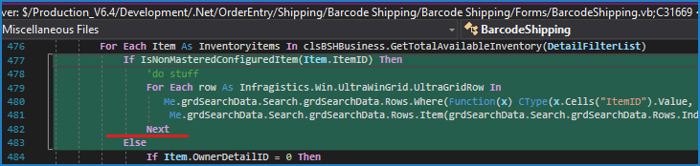

Comments (Useful, explains why rather than how)

Message Boxes (Grammar, spelling, captions, appropriate icons)

Ticket Management (Release Branch?, Testing Notes)

Extras
- It seems that this change is meant to display the quantity available like how Shipping will consume that inventory for product line items. My understanding of how Shipping can gather inventory for this type of item is that this is only one part of what it can do.
  - After checking for inventory created by a related work order, it will then look for inventory created by a related receipt if the item is a buy/non-stock item (item type of 1), and then it looks for inventory with the same Spec ID that is not created by a work order that is associated to a sales order. The last stage is quite unlikely and see now that it ignores the possibility that the inventory was created by a receipt for a sales order (same filter as above). Note that this should be confirmed, but I did review the .NET code and it does appear that this is correct, although I have left some filters out of the description. I wrote the original VB6 code that checks inventory in stages. I do not think I have left out anything that RelieveInventory does for shipping/invoice.
  - Discussing this with Shawn, this outstanding behaviour can be pushed to a new ticket that is referenced in this one, instead of making additional changes here. In addition, a second ticket, removing the SpecID fallback from the RelieveInventory methods can be created, instead of including that as outstanding behaviour in the first ticket, as this is not easy to create without database manipulation. Typically the client would simply create inventory via an adjustment and manually allocate it to a sales order or shipment. Please feel free to discuss this with Shawn.

